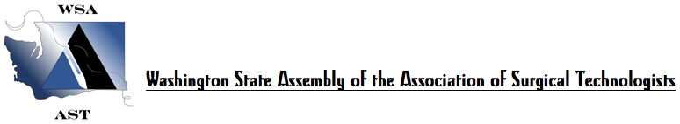SATURDAY, OCTOBER 19, 2019
2019 FALL WORKSHOP, ANNUAL BUSINESS MEETING AND ELECTIONS, 6 CE’s
SPOKANE COMMUNITY COLLEGE, SPOKANE, WA

0700-0750 Registration and Continental Breakfast

0750-0800 Welcome, Introductions, Announcements

0800-0845 Annual Business Meeting- Session 1:
Officer reports. Committee Reports. Announcement of Elections – Nominations from the floor for President, Vice- President, Treasurer and 2 Board of Directors, 6 Delegates & 6 Alternates to National Conference, Atlanta, GA.

0845-0900 Morning Break/ Door Prizes/Raffles

0900-0950 Miguel Schmitz, M.D. - Spinal Surgery & Hands On with Nick Mason from Globus

0950-1000 Business Meeting Session 2: Confirmation of Candidates and Candidate Statements.

1000-1150 Hassan Tehrani, M.D., FACS, MBA – Transcatheter Valve Therapies
with Terra Lawson-Gilbert, CST/CFSA

1200-1250 Voting/Lunch

1250-1330 Business Meeting #3: Recognition of Out Going Officers. Election Results. Swearing-in of New Officers. New Business. Adjournment.

1330-1420 Jennifer Whitworth, CST – Effective Precepting

1420-1430 Afternoon Break/ Door Prizes/Raffles

1430-1610 Stop the Bleed Training – Hands on Training and Certification

1610-1630 Final Raffles and Evaluations

Thank you for your attendance today. Stay tuned and anticipate announcements soon of our spring 2-day workshop and 14th Annual Scrub Bowl in March of 2020.

