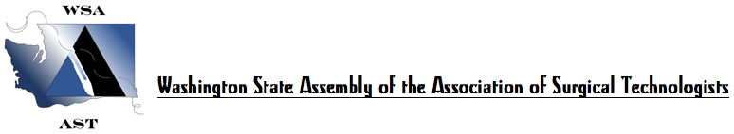SATURDAY, OCTOBER 20, 2018
2018 FALL WORKSHOP, ANNUAL BUSINESS MEETING AND ELECTIONS, 6 CE’s
KADLEC MEDICAL CENTER, RICHLAND, WA

0700-0750 Registration and Continental Breakfast

0750-0800 Welcome, Introductions, Announcements

0800-0845 Annual Business Meeting- Session 1:
Officer reports. Committee Reports. Announcement of Elections – Nominations from the floor for Secretary, 3 Board of Directors, 6 Delegates & 6 Alternates to National Conference, National Harbor, MD.

0845-0900 Morning Break/ Door Prizes/Raffles

0900-0950 Andrew J. Beiber, D.O. – Trauma, Tumors, and Technology in Neurosurgery

0950-1000 Business Meeting Session 2: Confirmation of Candidates and Candidate Statements.

1000-1050 Luay D. F. Ailabouni, MD – Robotic Colorectal Surgery

1100-1150 Kellen Stromberg, D.O. – Facial Trauma

1200-1250 Voting/Lunch

1250-1330 Business Meeting #3: Recognition of Out Going Officers. Election Results. Swearing-in of New Officers. New Business. Adjournment.

1330-1420 Mikel E. Shans, MBA MSL, CRCST, CER, CIS & CIL The Ins & Outs Of Sterilization

1430-1520 Ricardo DoValle, Sales, B.S. Orthopedic Joint Reconstruction: Knees, Hips & Shoulders

1530-1620 Mike Marquardt, Spine Specialist – Extreme Lateral Interbody Fusion

1620-1730 Final Raffles and Attendance Certificates

Thank you for your attendance today. Stay tuned and anticipate announcements soon of our spring 2-day workshop and 13th Annual Scrub Bowl in March of 2019.

