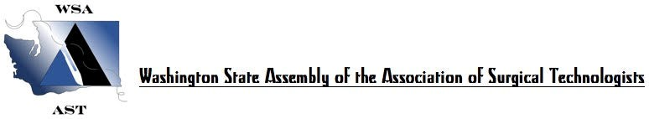

WSA 2020 SPRING FLING
WORKSHOP AND ANNUAL SCRUB BOWL
SATURDAY, MARCH 14, 2020(5 CE’S)
SEATTLE CHILDREN’S HOSPITAL, SEATTLE, WASHINGTON

0700-0750 Registration and Continental Breakfast

0750-0800 Welcome, Introductions, Announcements

0800-0850 Dr. Raymond Tse, Discussion of Cleft Palate

0850-0940 Dr. Corrie Anderson, “What are they doing over there?”

0940-1000 Morning Break/Raffles /Door Prizes/Vendor Tables

1000-1050 KeLicia Shorts, Health System Specialist, Applied Medical, “New Technologies in General Surgery”

1050-1140 Dr. Suzanne Yandow, Discussion of Hip Osteotomy

1145-1245 Lunch by Chef Linn Vendor Tables

1245-1335 Joe Jones, Hip Osteotomy Hands On Lab

1320-1400 Conclusion: End of day Raffles/Door Prizes/Evaluations/Scrub Bowl Announcements

1430-? 14th Annual Student Scrub Bowl

Thank you to our visitors today from Seattle Children’s Hospital, Swedish Hospital Systems, Applied Medical and Surgical Science.

WSA 2020 SPRING FLING
WORKSHOP AND ANNUAL SCRUB BOWL
SUNDAY, MARCH 15, 2020 (5 CE’S)
SEATTLE CHILDREN’S HOSPITAL, SEATTLE, WASHINGTON

0730-0800 Registration and Coffee

0800-0850 Dr. Patrick Healey, “What is the Kasai Procedure?”

0850-0940 Dr. Antoinette Lindberg, “What is a Rotationplasty?”

0940-0955 Break & Raffles

0955-1045 Becky Larson and Brian Norris from Surgical Science, “Why Laparoscopic Simulations?”

1045-1135 Dr. Kathy Sie, Discussion on Microtia

1135-1225 Dr. John Meehan, “Pectus Repair with Nerve Cryo”

1225-1245 Conclusion: End of day Raffles and Evaluations

Thank you for your attendance this weekend. Look out for details of our fall event in October, 2020. This one-day event will include 6 CE’s and our annual elections. More details to follow. Look for emails and Facebook posts soon.

